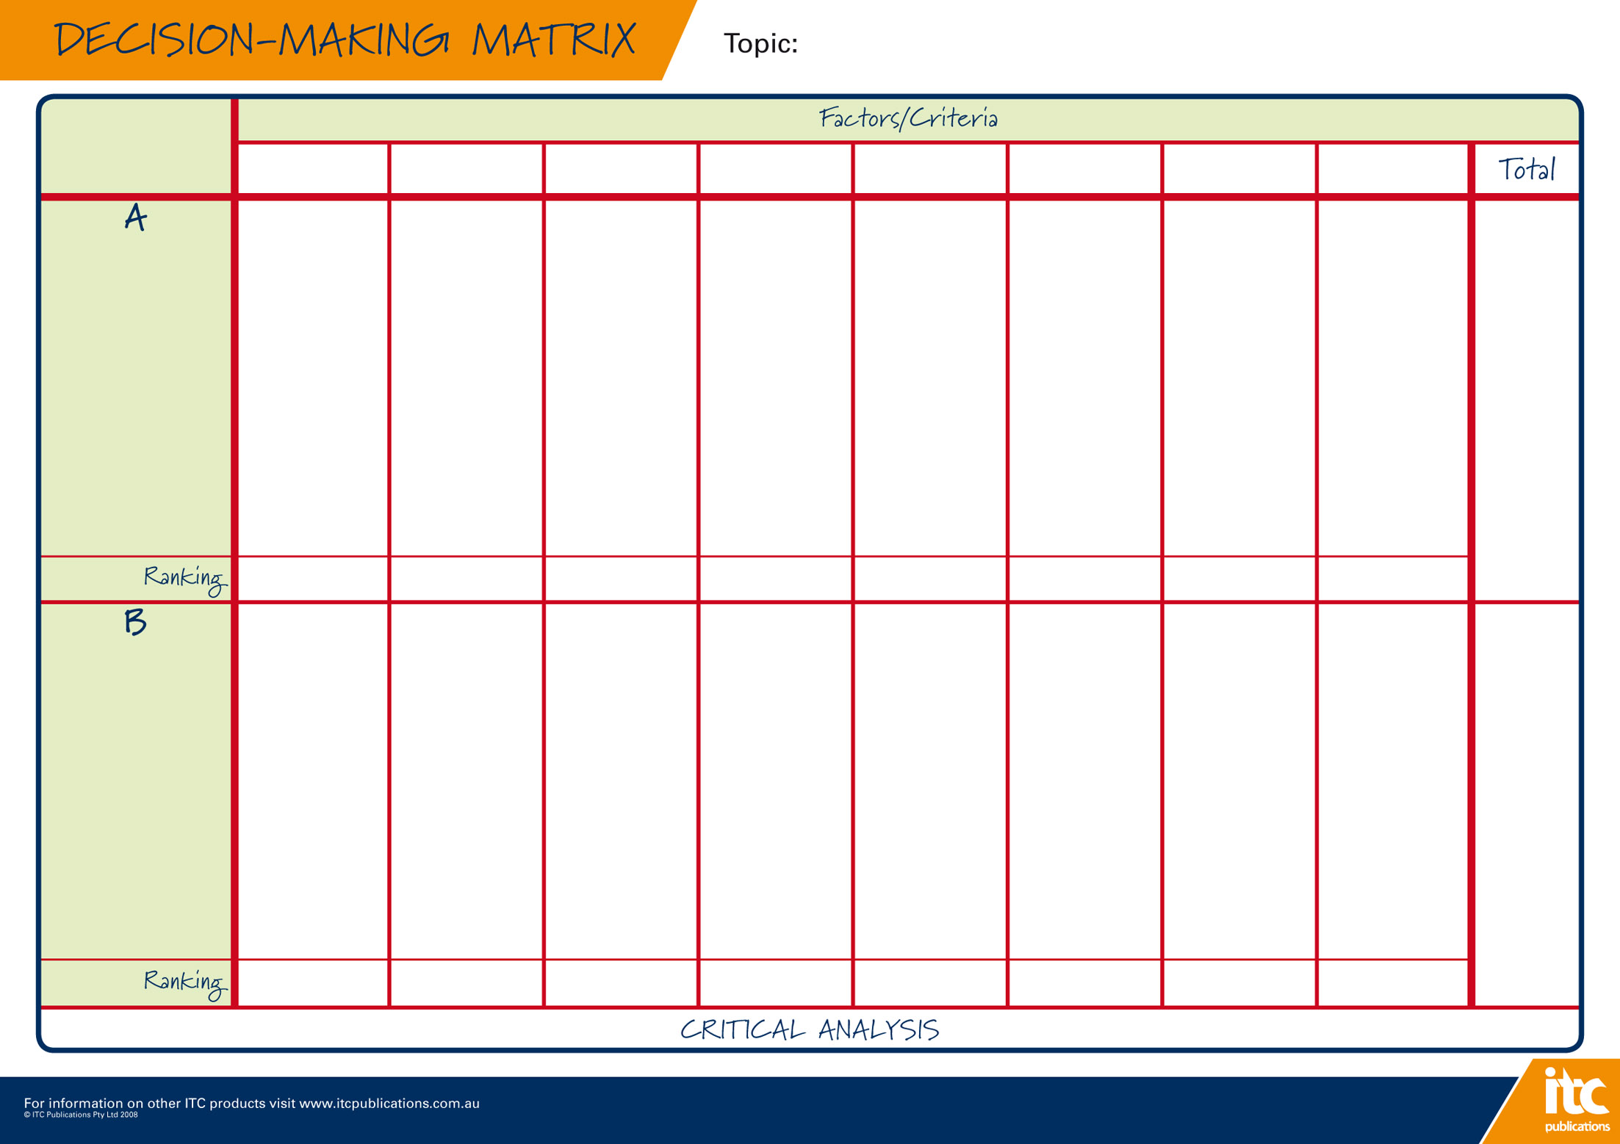
 |  |  |  |  |  |  |  |  | Choosing a BYOx\PYOD laptop (comparison of vendors and models)
 |  | Meets min. specs? | Cost of laptop |  | Warranty arrangements |  |  | Support arrangements |  |  | Accidental Damage | Hard protective case | Finance (if applicable): | Other:
Vendor\retailer name:  Laptop brand and model: |  |  |  | Enter details of cost: |  | Enter details of warranty: | Enter details of support arrangements: |  |  | Enter details of accidental damage options: |  | Enter cost and details of hard protective case (not rubber sleeve) here: | Enter details of finance arrangements (if applicable) here: |  | Total Score for this vendor\  retailer:  /80
 | Score /10 |  |  | Score /10 |  | Score /10 | Score /10 |  |  | Score /10 |  | Score /10 | Score /10 | Score /10
Vendor\retailer name:  Laptop brand and model: |  |  |  | Enter details of cost: |  | Enter details of warranty: | Enter details of support arrangements: |  |  | Enter details of accidental damage options: |  | Enter cost and details of hard protective case (not rubber sleeve) here: | Enter details of finance arrangements (if applicable) here: |  | Total Score for this vendor\  retailer:  /80
 | /10 |  |  | /10 |  | /10 | /10 |  |  | /10 |  | /10 | /10 | /10

