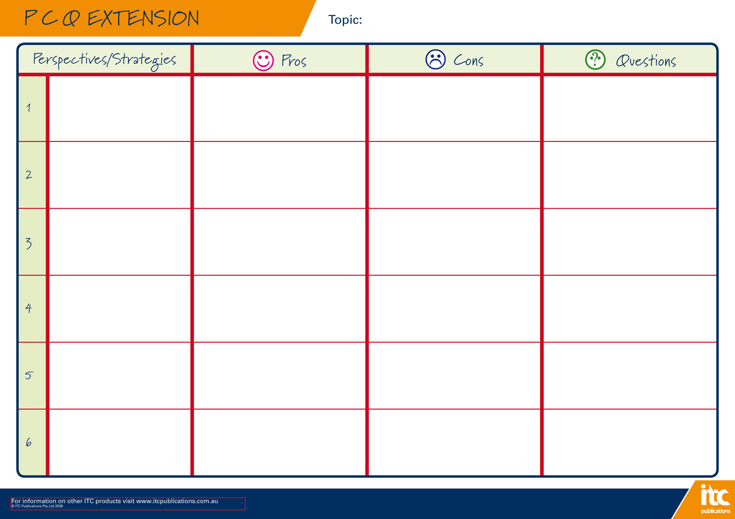

**Laptop suitability for BYOx\PYOD program**

Vendor\retailer:

Laptop brand and model:

|  |  |  |  |
| --- | --- | --- | --- |
| **Meets min. specs?** |  |  |  |
| **Cost of laptop:** |  |  |  |
| **Warranty arrangements:** |  |  |  |
| **Support arrangements:** |  |  |  |
| **Accidental Damage:** |  |  |  |
| **Finance (if applicable)** |  |  |  |